**ASSIGNMENT -10**

**AIM:** To implement MYSQL database connectivity with java for database navigation operations such as insert, delete, update using ODBC/JDBC.

**CODE:**

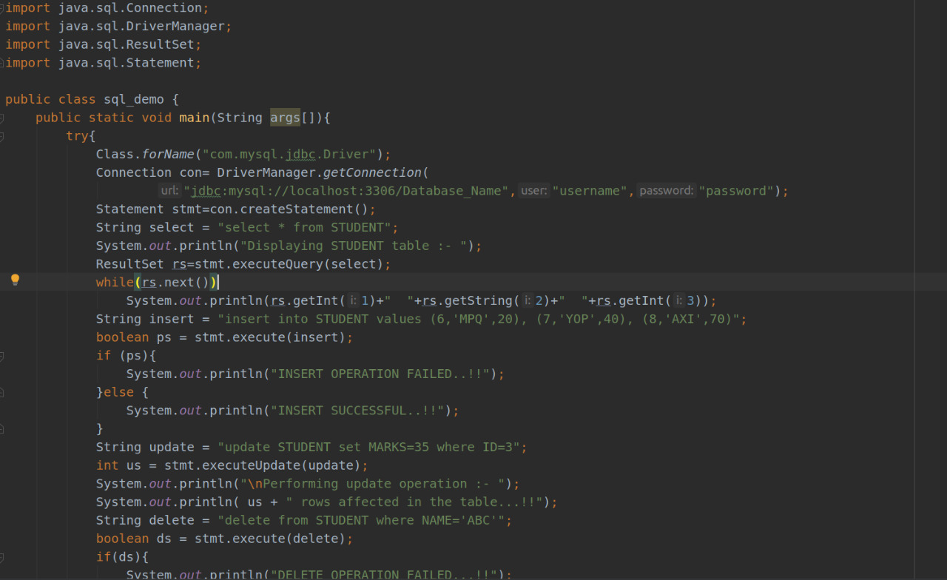

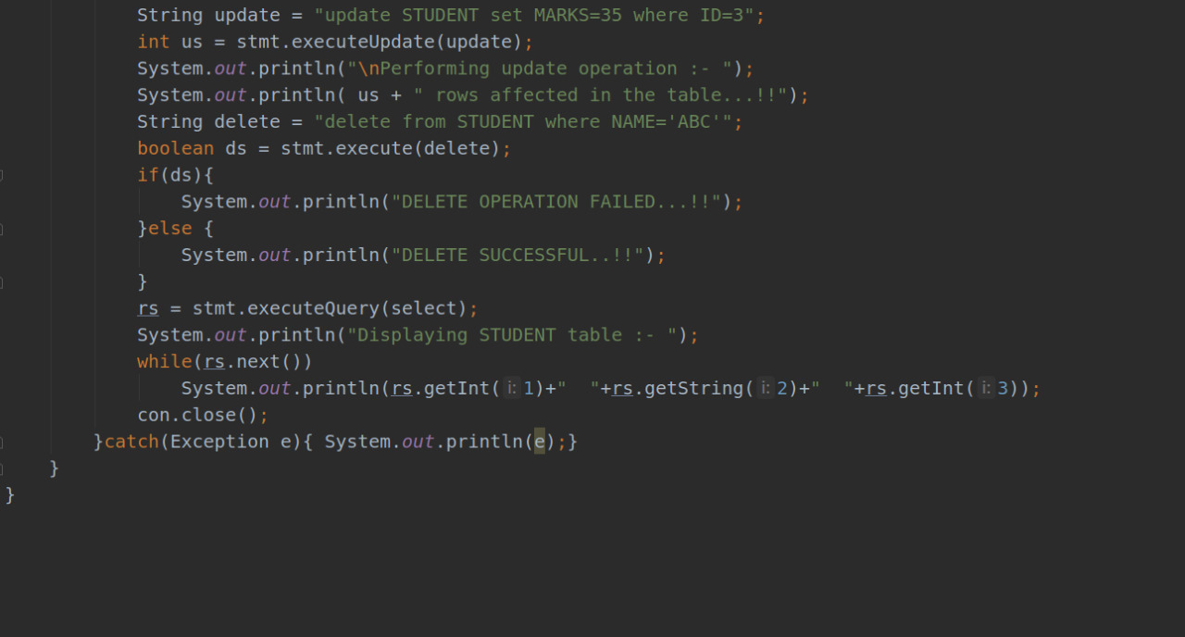

**OUTPUT:**

